*Project 3*

Step1:Create two linux instances,Use the first free linux AMI

ss1:instances list

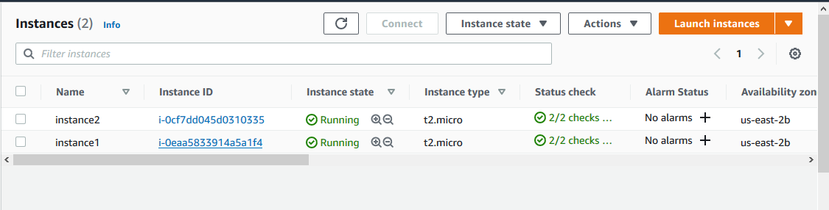

ss2:select a instance and display instance details of server1

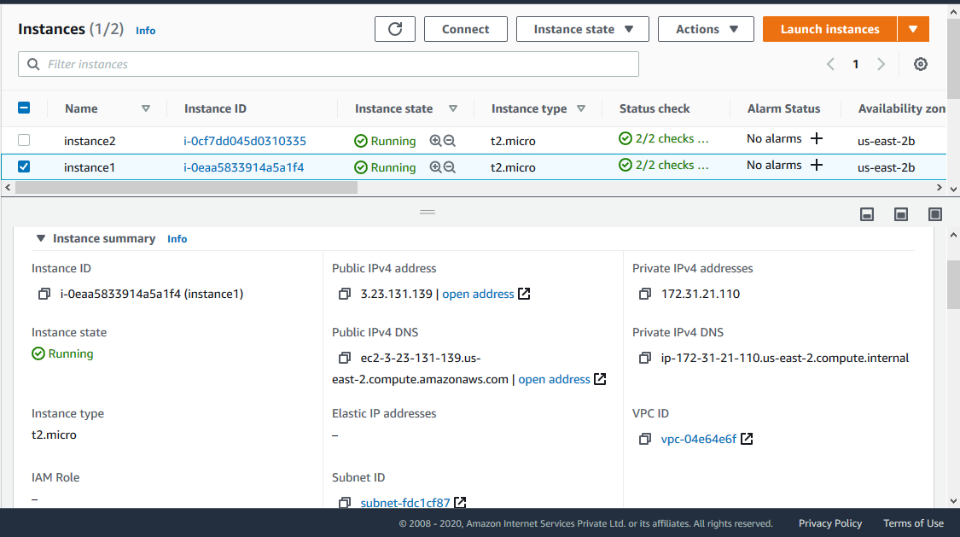

ss3:select a instance and display instance details of server2

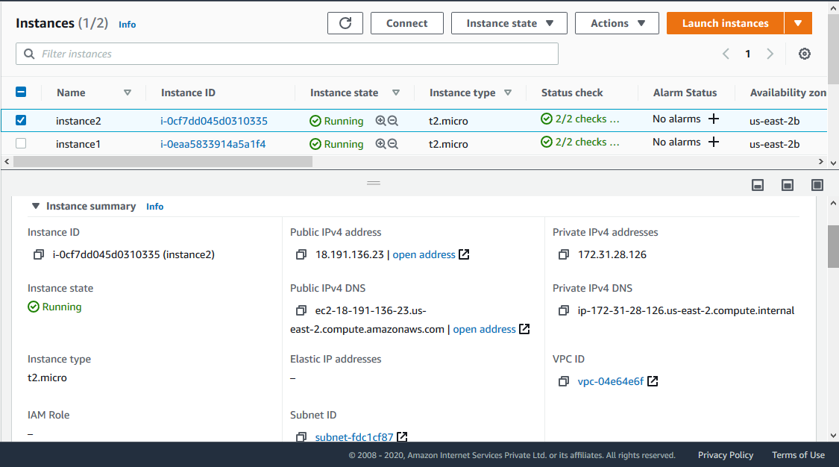

ss4:Status:Active running- black screen

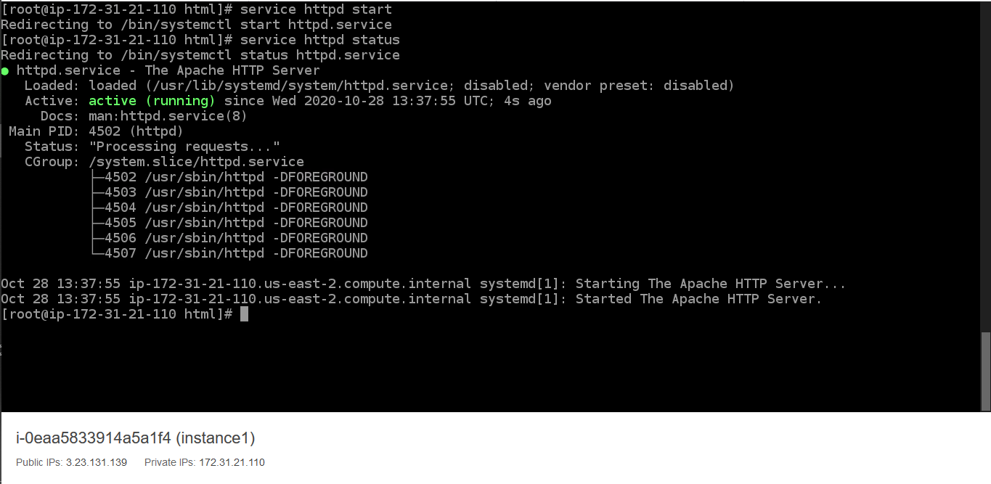

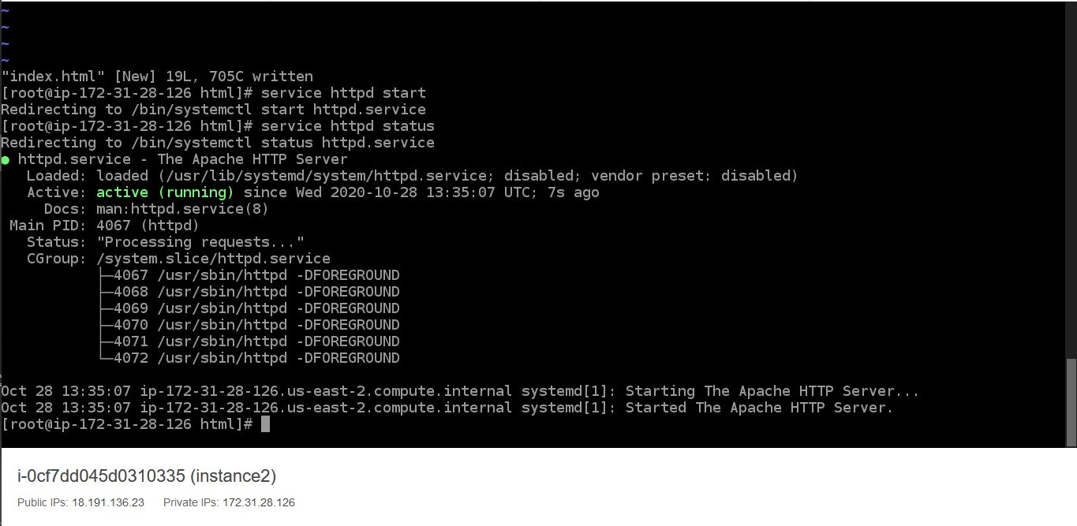

ss5:username password page

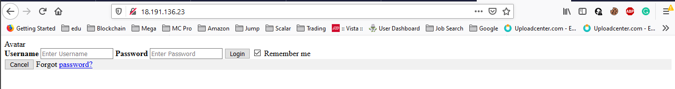

ss6:userid passkey

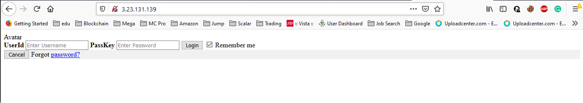

Step5:Create a application Load balancer with the above two instances as targets

ss7:Load balancer screenshot

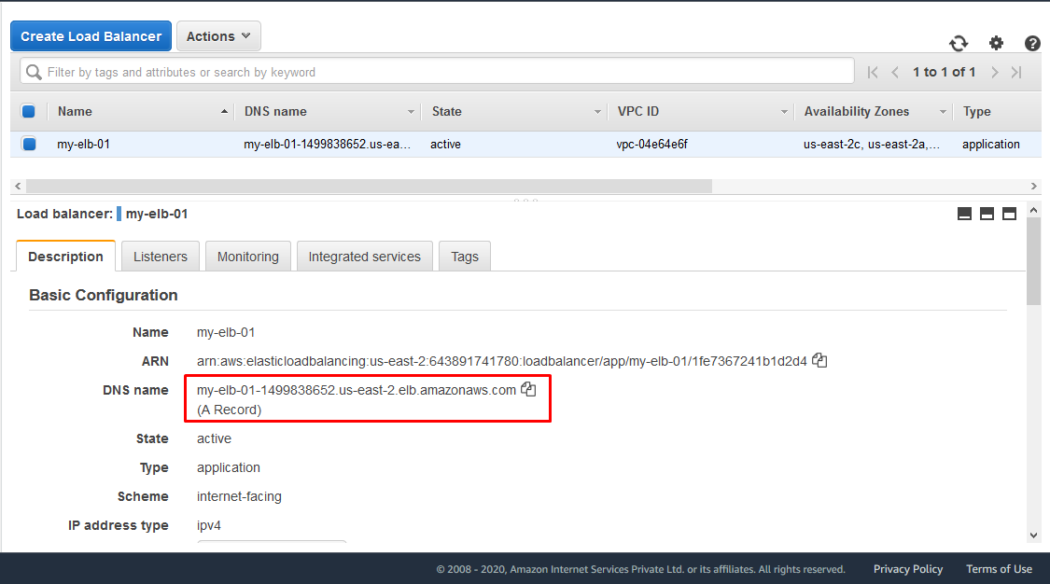

Step6:Check the functioning of ELB using the DNS of the ELB

use the dns

ss8:reply from server1

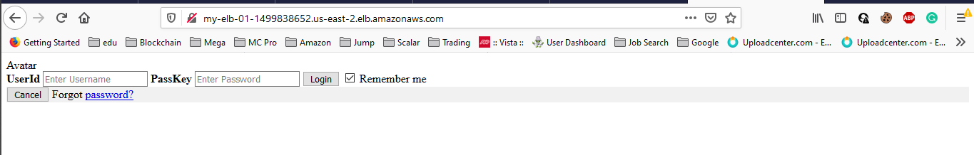

ss9:reply from server2

